Defining your web site to Dreamweaver

Dreamweaver from Adobe helps you create your web pages on your local computer and can then transfer them to your web host so that your pages can be accessed from anywhere in the world.
Dreamweaver needs to know the location of the pages on your computer and it needs to know where your web host is located and how to access your web host. This information is specified to Dreamweaver by creating a new site. Instead of typing all the information required by Dreamweaver, you can import this information in a file. The file you need has been provided for you in Blackboard. The provided file assumes that you will be using an external drive located at drive letter e:. You will not need much space on this drive so a small thumb drive will be sufficient. If your drive letter will be different the “e:”, you will specify this later.
Download the small site definition file attached to this Blackboard item. Click on the file corresponding to your group and save it to your local computer. In this example, the file for group 35 (mysite35.ste) has been saved to the desktop on the local machine.
Attach your external drive to your computer (or to Dominican’s computer) and then start Dreamweaver.
Click on the Site menu item (see above) and select “Manage Sites”. This is display a dialog box like the one shown below.
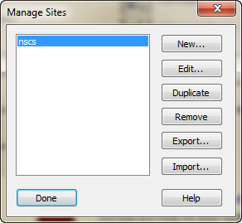
Click on “Import.. “ and select the file that you saved earlier from Blackboard.
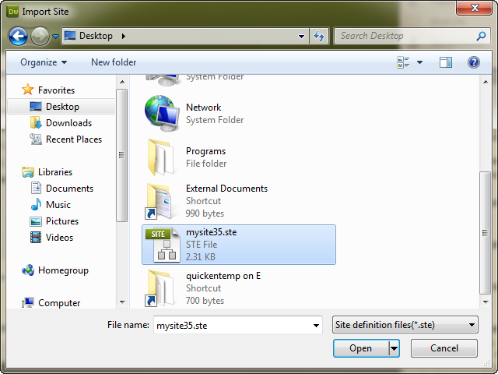

You may receive a message that looks like this:
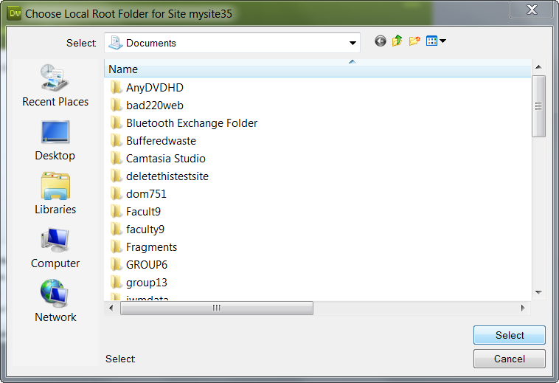
Click on Computer
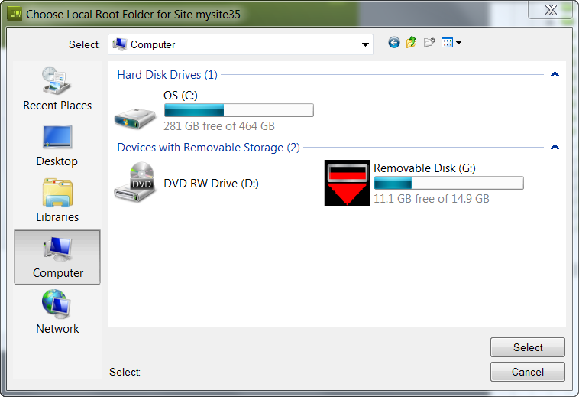
Select your Flashdrive
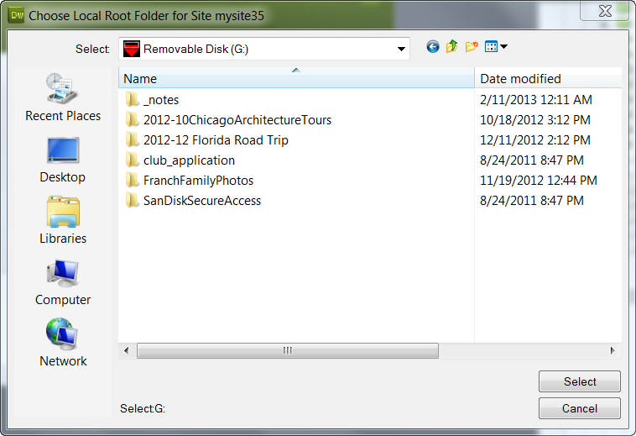
Create a folder on your flash drive as shown below. The new folder icon is the second icon from the right
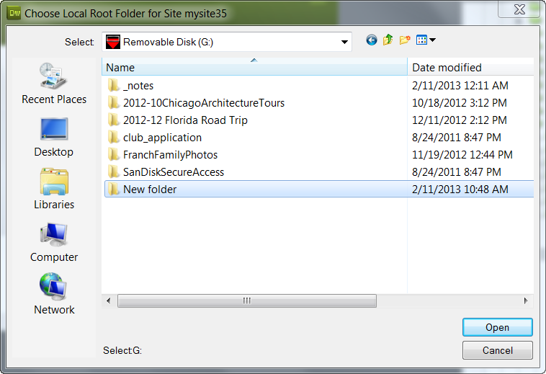
Type a name for the folder
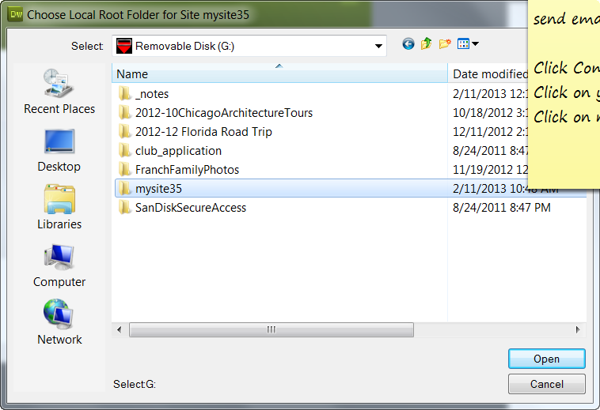

The click “Open” and then “Select”. Your site is now defined to Dreamweaver.
You can edit the site by clicking Edit if needed. This should not be necessary.
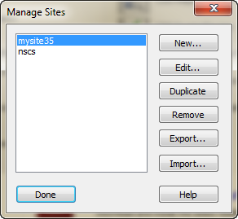

Dreamweaver will open the site definition that you just imported.
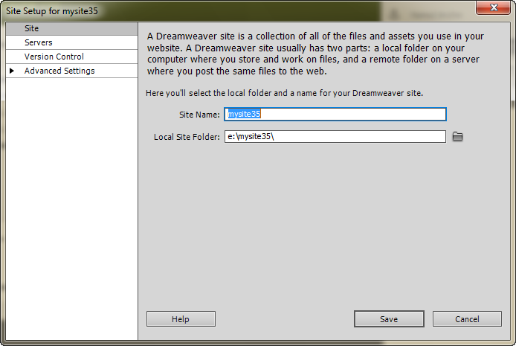

If you want to change the location of where your local copy of your site will be located, click the small icon to the right of “Local Site Folder”.

Next, verify that the file you just imported will successfully access the space on the server assigned to your group. To do this, go (back) to Dreamweaver and click on Servers.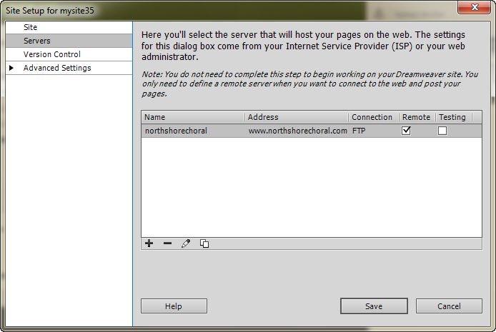
Then, double click on northshorechoral.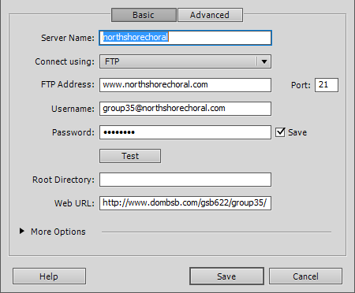

You can see the information that has been provided for your group. Click the Test button to verify that this information is correct and allows you to connect to the server.
You will see the following:
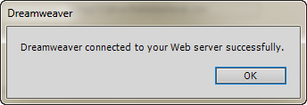
If you did not connect to the server successfully ask a classmate for help or email me at jmiller@dom.edu.
Click “OK” to clear the Dreamweaver connected box (shown above) and return to the “Server Name” dialog. The click Save to return to the Servers dialog and finally click Save again to return to the Manager Sites dialog shown below. You should now see your site in the list. In this example, you can see that mysite35 has been added to the list.

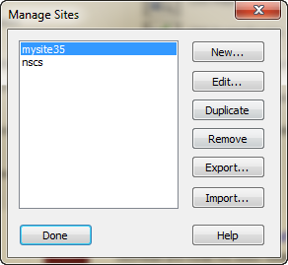
Click Done to close the Dialog.

We are now ready to use Dreamweaver to create new pages or modify existing pages on our site. Just to prove that everything is working, here is an example of how to retrieve a page from the site, change it and put it back.
Go to the right side of the Dreamweaver Screen and change Local View to Remove Server. Your screen should then look something like this:

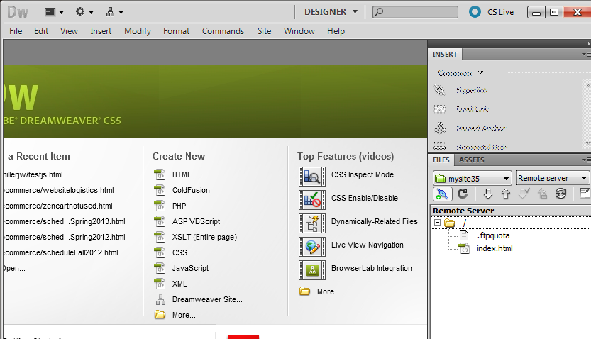

Double click on “index.html” on the right side of the screen. Answer “Yes” if a “Get dependent files” message appears. You should see the current home page on your site.
In this example, I have added an additional line with the words “I have just changed index html” in small print.
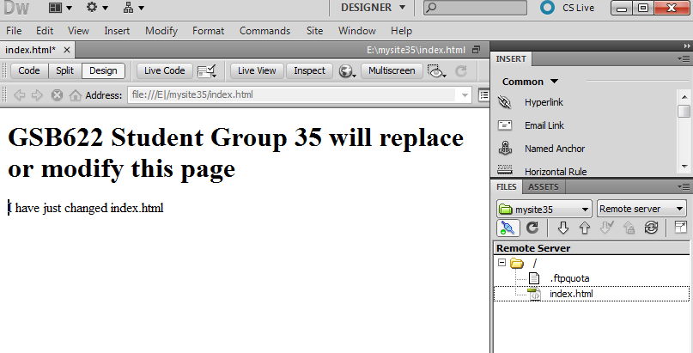

Next, save your work (File / Save), and then put your changed page back to the site (Site / Put). Answer “Yes” to the Put Dependent Files message. Your site is now updated. View it by going to http://www.dombsb.com and then clicking on “GSB622 Students” and then clicking your group number. You should see something like this.